**OBJECTIVES:** To identify global trends in suicide rates over three decades (1985-2016)

Determine the impact of economic recessions on suicide rates.

**Key Insights from Analysis of Suicide Rates (1985-2016) and Economic Indicators**

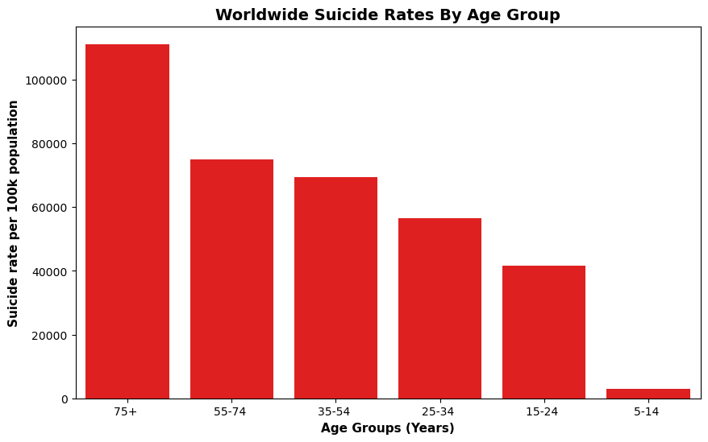

**Fig 1. Global Suicide Rates (1985-2016) By Age Groups**

The analysis of global suicide rate trends from 1985 to 2016 highlights significant variations across different age groups. The 75+ years age group consistently recorded the highest suicide rates, as illustrated in Figure 1. Additionally, Figure 2b reveals a notable surge in suicide rates in 2002 among the Silent Generation—individuals born between the 1920s and 1940s. This increase significantly influenced the overall rise in suicide rates among those aged 75 and older.

Several factors may have contributed to this trend, including social isolation, financial insecurity after retirement, declining physical health, and possible psychological trauma from past wars. However, a sharp decline was observed over time, particularly between 2011 and 2016, which may be attributed to enhanced mental health awareness, improved access to support systems, and more effective suicide prevention initiatives.

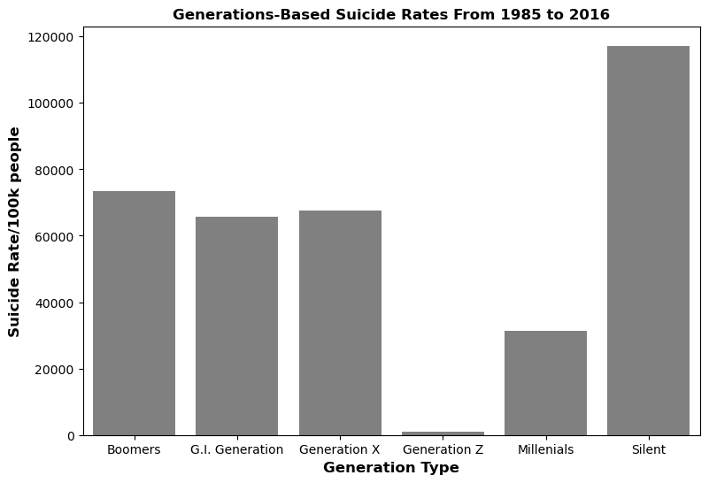

**Fig 2a. Global Suicide Rates (1985-2015) By Generation Types**

**Fig 2b. Yearly Suicide Rates Among Generation Silent (1985-2015)**

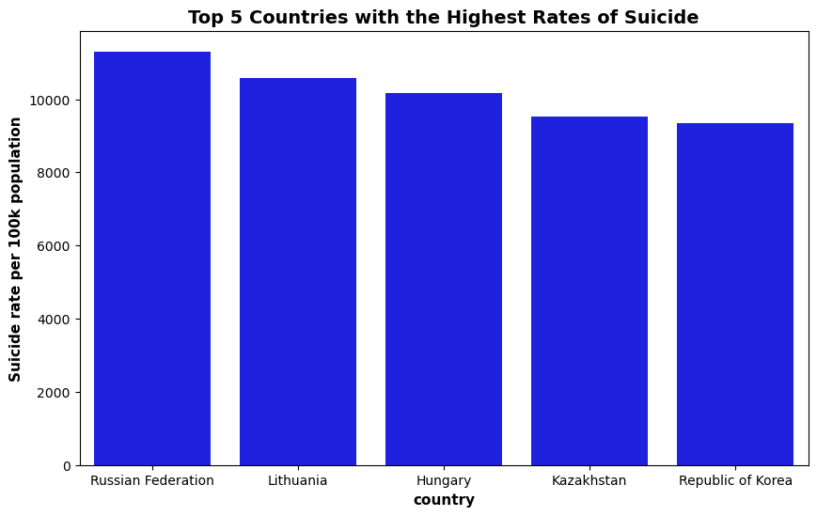

**Fig 3a. Top 5 Countries with the Highest Suicide Rates (1985-2015)**

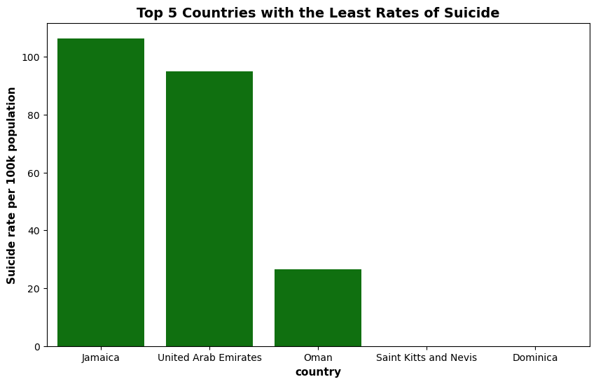

**Fig 3b. Countries with the Least Suicide Rates (1985-2015)**

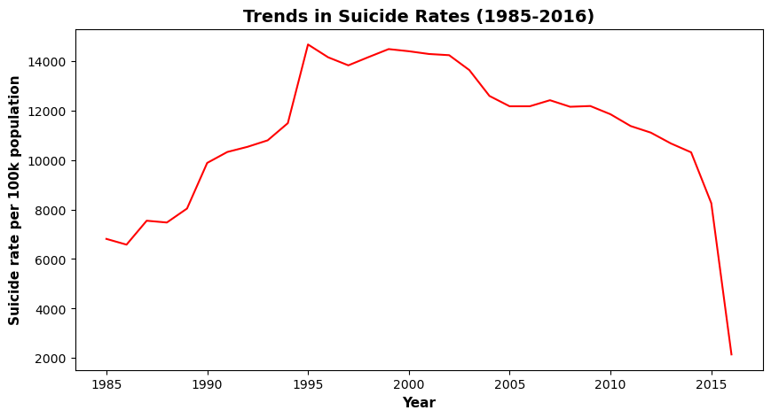

**Fig.4 Global Trends in Suicide Rates from 1985-2016**

Figures 2 and 3 illustrate suicide rate trends across various countries and continents between 1985 and 2016. Figure 1 highlights the top five countries with the highest suicide rates per 100,000 population, while Figure 2 presents the five countries with the lowest recorded suicide rates per 100,000 population.

Among the countries analyzed, the Russian Federation recorded the highest suicide rate at 11,305.13 per 100,000 population, while Oman had the lowest recorded rate at 26.50 (check python notebook). Furthermore, no suicide cases were reported in Dominica and Saint Kitts and Nevis during the observed period.

On a global scale, suicide rates declined by 68.48% between 1985 and 2015. Despite Russia having the highest suicide rate, it has demonstrated a steady decline over time, as illustrated in Figure 4.

**DEMOGRAPHIC GROUPING PER SUICIDE RATES** 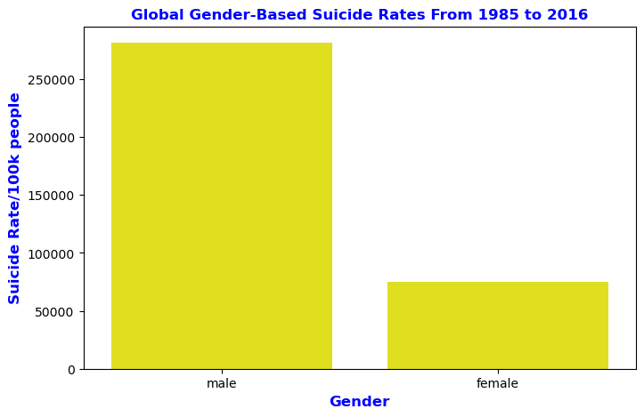

**Fig 5. Suicide Rates by Gender (1985-2016)**

A total of 6,748,420 suicide deaths (reference: Python notebook) were recorded between 1985 and 2016, with male subjects accounting for 5,188,910 and females 1,559,510. This confirms that suicide rates were significantly higher among males than females.

The high suicide rates observed across various countries contributed to the overall global suicide deaths. Several factors may explain the higher prevalence among men, including increased likelihood of alcohol dependence, social isolation, and impulsive behavior. Additionally, many men may avoid seeking help due to societal pressures to maintain self-respect and emotional resilience. Moreover, since a large number of men tie their identity to their careers, job-related setbacks, unemployment, or extended periods of idleness can lead to severe depression, which may ultimately result in suicide.

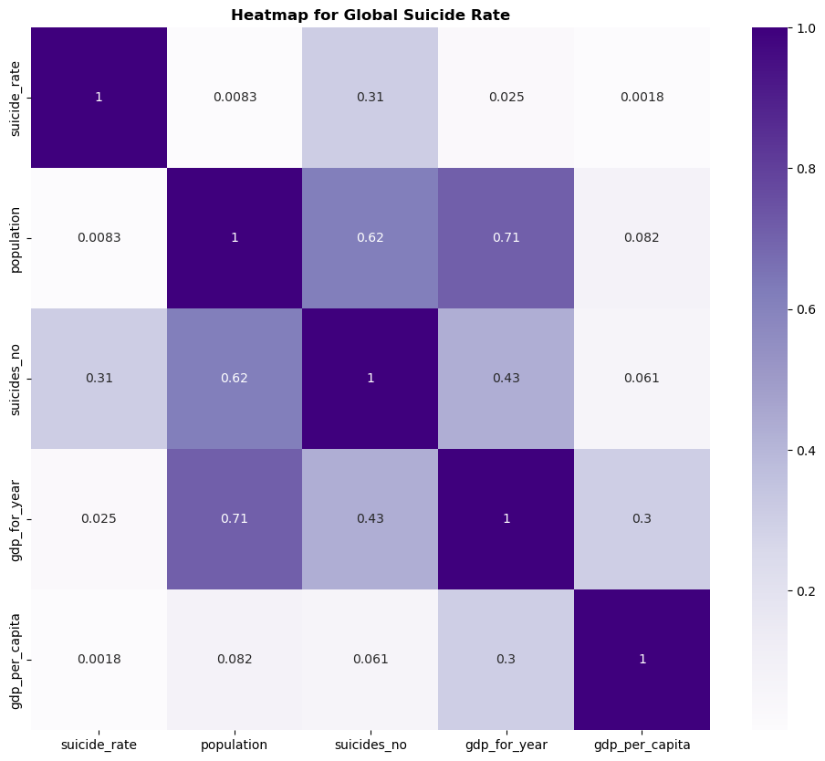

**Fig 6. Impact of Economic Indicators on Suicide Rates: An Heatmap Analysis**

In the correlation heatmap analysis, the relationship between GDP per capital and Annual GDP with suicide rates over the three (3) decades yielded correlation coefficients of 0.0018 and 0.025 respectively. These values indicate a very weak correlation between this economic indicator (Gross Domestic Product (GDP)) and suicide rates.

While GDP is an important economic indicator, its weak relationship with suicide rates is suggestive that other economic and social impact may play more influential role in determining across different countries over the years. Also, GDP relationships with suicide rates might vary globally thereby affecting the overall impact of GDP on suicide rates.